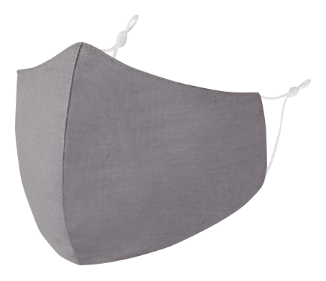
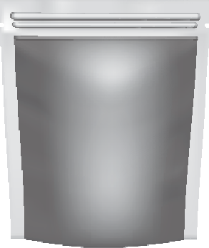
www.maskitmasks.com.au @maskitmasks

Removable PM2.5 filter protects against airbourne particles

Rubber adjuster on ear loops for a tailored fit

naturally breathable cotton

REUSABLE ZIP LOCK STORAGE BAG

Adjustable straps guarantee they stay in place and provide a tailored more comfortable fit for your face.
Durable cotton outer layer can be machine washed at 60o celcius as recommended by the Department of Health and Human Services.
Pack includes 3 x PM2.5 filters which provide 5 layers of safety. Two anit-stick non-woven cloth layers block moisture and large particles, two electrostatic filters attracts stray particles and the inner carbon filter prevents the transmission of microscopic airborne particles.

Easy care machine washable and
tumble dryer friendly.
Two layers of cotton are naturally
breathable so it doesn’t get sweaty or itchy.

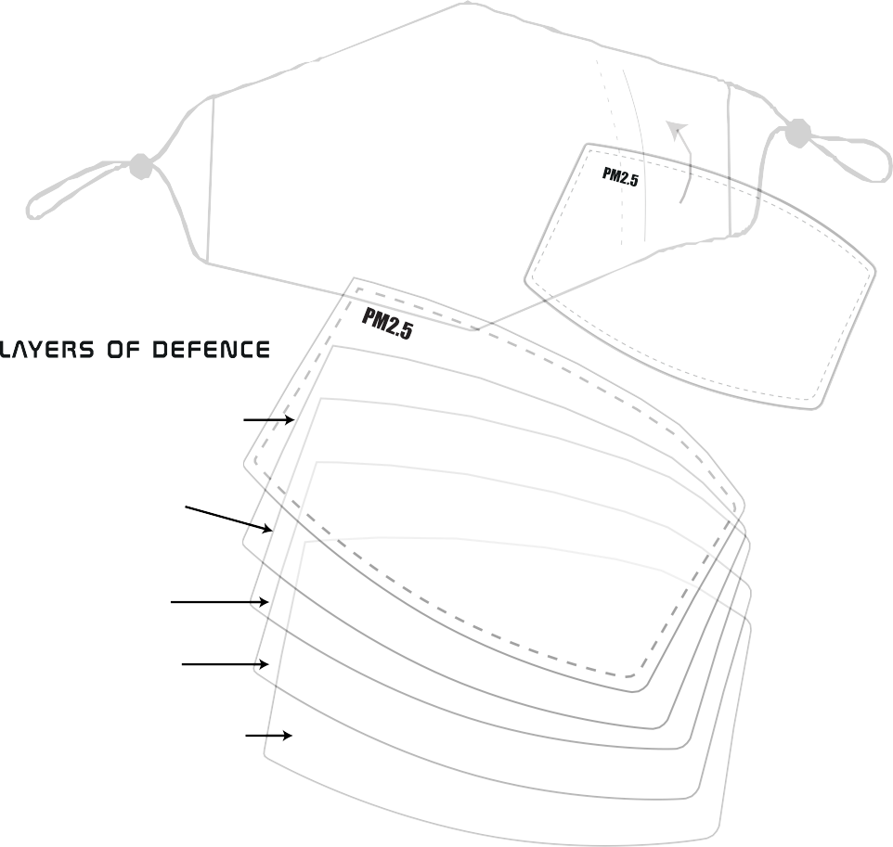

MASKiT is the BEST VALUE fashion face mask in Australia! Not only are our masks ON TREND but super comfortable too.

Filter Insert

Anit-stick non-woven cloth filters moisture and large particles

Electrostatic filter attracts stray particles

Carbon filter prevents the transmission of
microscopic airborne particles
Electrostatic filter attracts stray particles

Anit-stick non-woven cloth filters moisture and large particles

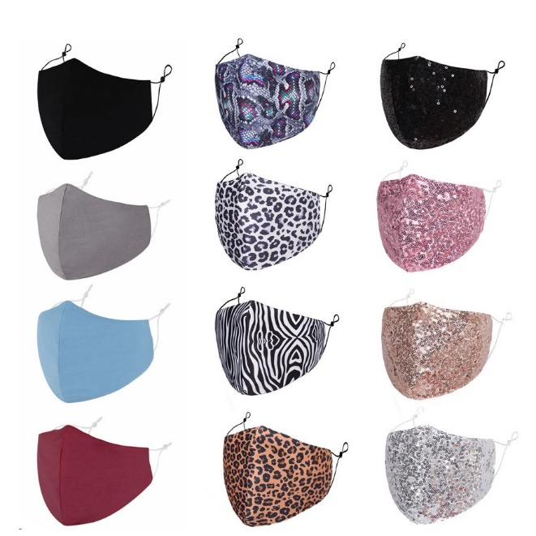
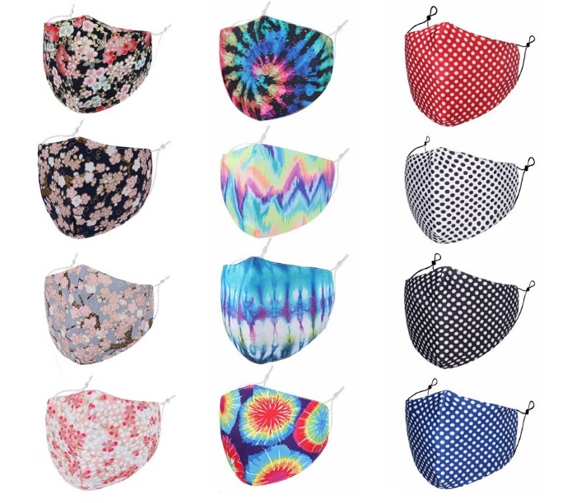
12MSP Maskit Starter Pack
52716 Maskit Face Mask Phase 1 (24) 144
52723 Maskit PM2.5 Mask Filter Set of 100 7
Total Buy 151 pieces $1000.00 plus GST

12MPP Maskit Pro Pack
52716 Maskit Face Mask Phase 1 (24) 1008
52723 Maskit PM2.5 Mask Filter Set of 100 24
Total Buy 1032 pieces $5,400.00 plus GST
(Included 10% discount)

Victoria
Shannon Fleming: 0412 350 989 shannonf@gibsongifts.com.au
Chris Vine: 0412 811 522 chrisv@gibsongifts.com.au
Maree Lewis: 0418 604 430 mareel@gibsongifts.com.au

Queensland
Peter Littin: 0402 084 066 peterl@gibsongifts.com.au
Rob Skinner: 0408 981 445 roberts@gibsongifts.com.au
New South Wales
Roger Olsson: 0412 775 506 rogero@gibsongifts.com.au

Caroline Roberts: 0417 359 422 caroliner@gibsongifts.com.au
Debbie Ashley: 0412 869 848 debbiea@gibsongifts.com.au
Vivienne Lee: 0412 050 430 viviennel@gibsongifts.com.au
Western Australia
Adam Hart: 0418 948 693 adamh@gibsongifts.com.au

South Australia
Marilyn Stewart: 0400 927 391 marilyns@gibsongifts.com.au
Tasmania
Tina King: 0407 680 377 tina@gibsongifts.com.au

81 Tulip Street Cheltenham, VIC 3192 Australia T: 03 9581 3666 F: 03 9583 9321 E: enquiries@gibsongifts.com.au gibsongifts.com.au

